**Assignment -3**

|  |  |
| --- | --- |
| Assignment Date | 10 October 2022 |
| Student Name | Soundariya |
| Student Roll Number | 723619104031 |
| Maximum Marks | 2 Marks |

**Question-1:**

1. Create a Bucket in IBM object storage.
2. Upload an 5 image to IBM object storage and make it public. write html code to displaying all the 5 images.
3. Upload a CSS page to the object storage and use the same page in your HTML code.
4. Design a chat bot using IBM Watson assistant for hospital. Ex: User comes with query to know the branches for that hospital in your city. Submit the web URL of that chat bot as a assigenment.

.

1. Create Watson assistant service with 10 steps and use 3 conditions in it. Load that script in HTML page.
2. **Create a Bucket in IBM object storage**

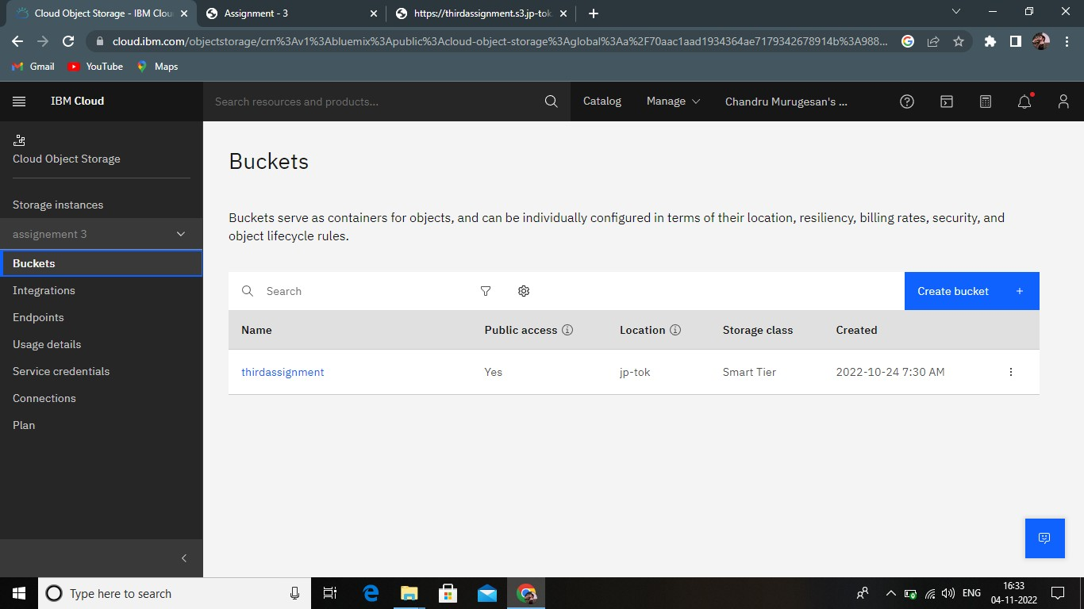

1. **Upload an 5 image to IBM object storage and make it public. write html code to displaying all the 5 images.**

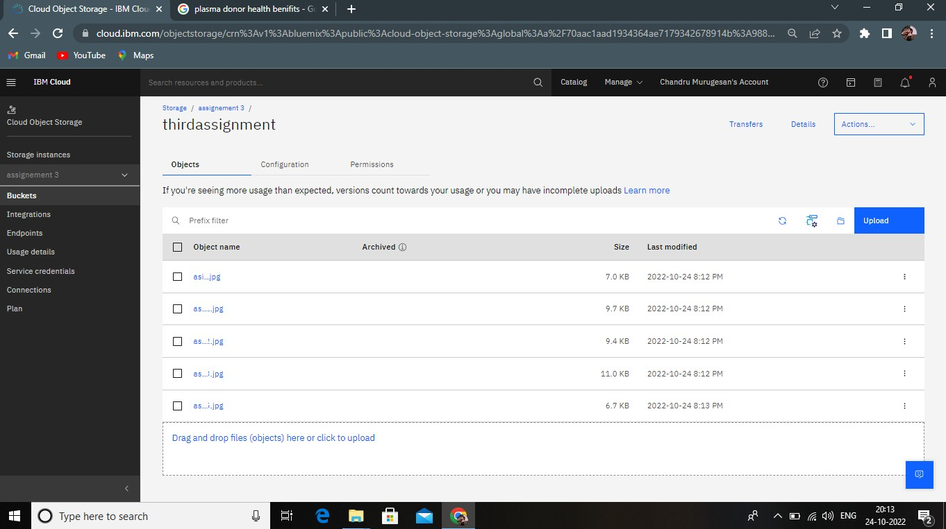

1. **Design a chat bot using IBM Watson assistant for hospital. Ex: User comes with query to know the branches for that hospital in your city. Submit the web URL of that chat bot as a assigenment**

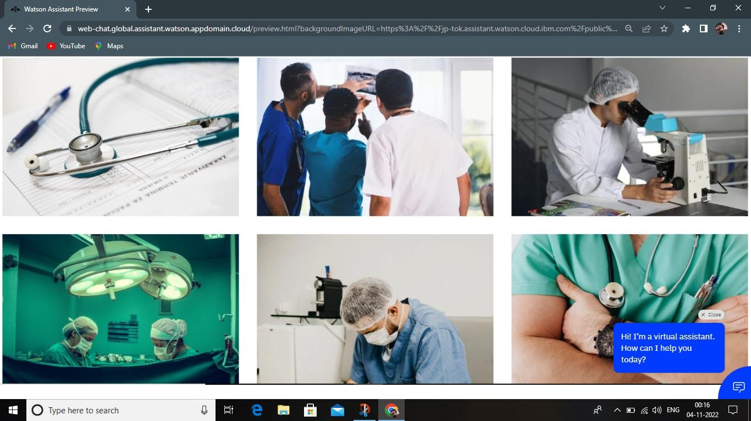

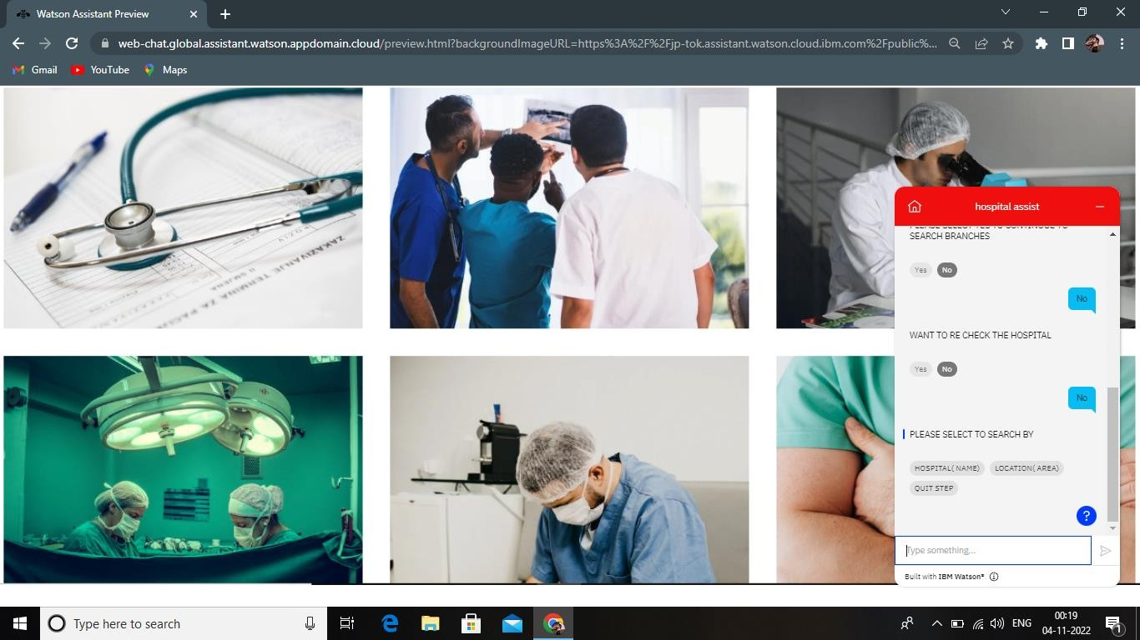

URL

https://web- chat.global.assistant.watson.appdomain.cloud/preview.html?backgroun dImageURL=https%3A%2F%2Fjp- tok.assistant.watson.cloud.ibm.com%2Fpublic%2Fimages%2Fupx- 8d8d206a-73c4-40eb-861e-7550e9f2532d%3A%3A8dea9163-d817-

# 4137-a3a8-0b1a34f40203&integrationID=c4f663b5-f35b-465b-be59- 1d89c0441d73&region=jp-tok&serviceInstanceID=8d8d206a-73c4- 40eb-861e-7550e9f2532d

1. **Create Watson assistant service with 10 steps and use 3 conditions in it. Load that script in HTML page.**

HTML CODE

<!DOCTYPE html>

<html lang="en">

<head>

<meta charset="UTF-8">

<meta http-equiv="X-UA-Compatible" content="IE=edge">

<meta name="viewport" content="width=device-width, initial-scale=1.0">

<title>Assignment - 3</title>

<link rel="stylesheet" href="./static.css">

</head>

<body>

<h1>Assignment 3 - CAD -- B3-3M5E - Plasma Donar Application</h1>

<div class="ImgSlider"></div>

<a href="https://ibb.co/WyGmDFR"><img src="https://i.ibb.co/Sn5FQ0Z/Screenshot-2022-11-03- 235314.png" alt="Screenshot-2022-11-03-235314" border="0"></a>

<script> window.watsonAssistantChatOptions = {

integrationID: "c4f663b5-f35b-465b-be59-1d89c0441d73", // The ID of this integration. region: "jp-tok", // The region your integration is hosted in.

serviceInstanceID: "8d8d206a-73c4-40eb-861e-7550e9f2532d", // The ID of your service instance.

onLoad: function(instance) { instance.render(); }

};

setTimeout(function(){

const t=document.createElement('script');

t.src="https://web-chat.global.assistant.watson.appdomain.cloud/versions/" + (window.watsonAssistantChatOptions.clientVersion || 'latest') + "/WatsonAssistantChatEntry.js";

document.head.appendChild(t);

});

</script>

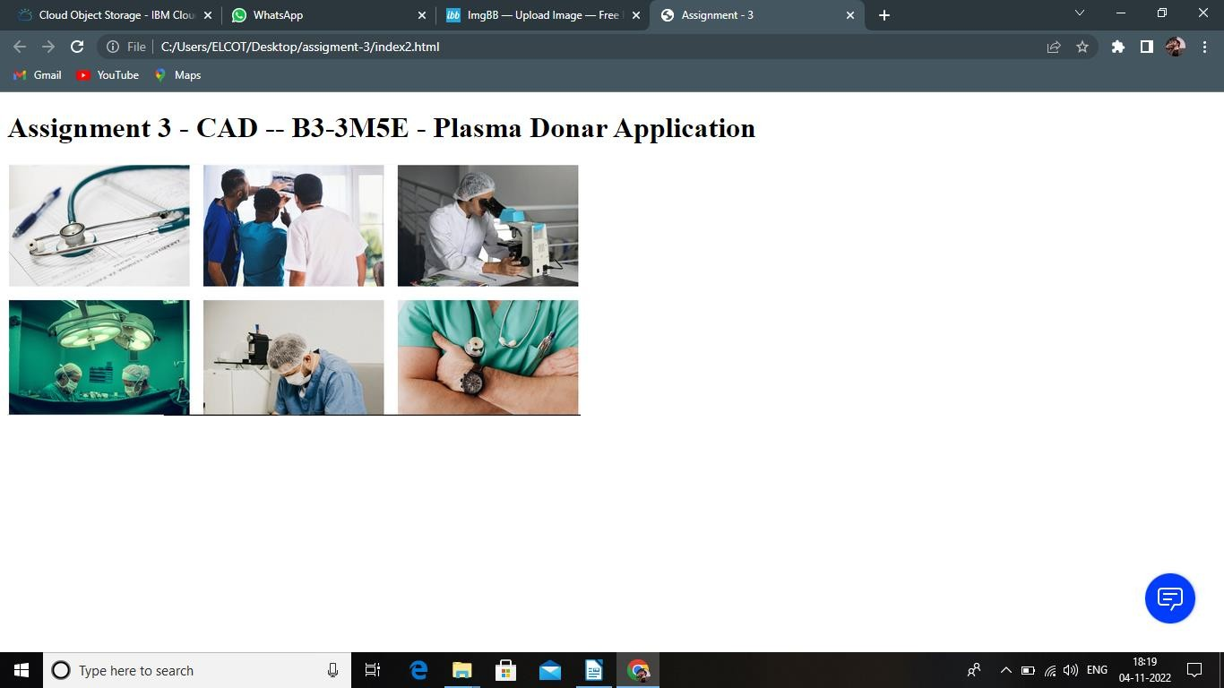</body>

</html>

